LeanFT is an automated functional testing tool which has been developed as an improved version of UFT (Unified Functional Testing). It has not been developed as a replacement to UFT, rather it is an extension to UFT along with features from Selenium — an open source automated testing tool for web applications.

LeanFT and UFT are not mutually exclusive. UFT includes the LeanFT plugin for creation of tests in Visual Studio/C# or Eclipse/Java. One can leverage the knowledge of UFT when working with LeanFT. LeanFT is a powerful functional testing tool which has been developed specifically for agile and DevOps software development methods. It reduces the testing time of the application and helps in the early identification of defects and errors. It does not, however, provide web wervice testing or a record and playback feature.

Selecting the right automated testing tool differs with the type of project. Both of HP’s functional testing tools are different in essential ways which need to be understood before choosing an automated testing solution.

UFT supports a range of technology, including legacy apps, web, and mobile services. It is intended for users who do not deal with the complex methods, making it a relatively user-friendly option. Its general user base is the QA, Business Analysts, testers and subject matter experts. The LeanFT solution is more appropriate for Agile, DevOps and Continuous Testing teams. This tool set speeds up the flow of testing and facilitates regular maintenance. UFT helps conduct regression tests. The identification and labeling of elements across completed tests ensures high-speed and economic delivery of projects. If a tester is well skilled in UFT, using LeanFT will be easier as the object identification mechanisms and same. Many of the features of LeanFT are enhanced and improved ones of UFT.

The UFT scripts work seamlessly with the dynamic data. This data can either be entered manually into the parameter table or can be imported from an external source. Another advantage of UFT is that debugging is significantly easier, as the entire testing process can be viewed as a smooth animation with its record and playback feature. This feature is not yet available in LeanFT. However, LeanFT’s full integration with standard IDEs results in better collaboration within agile teams. Its templates for standard unit testing reduces the time required to test apps, and rectifies errors in the early stages of development. Also, LeanFT’s continuous, real time vulnerability testing further eliminates the need for special security measures.

**Conclusion**

UFT and LeanFT can be thought of as a two intersecting circles in a Venn Diagram. Both have common features and well as those which are unique to each other. They target different user groups as well. One fact that cannot be denied is that for the fluent use of LeanFT, practical knowledge of UFT is very leveraging. Hence, as per the testing requirements, the depth of software development model and the type of user at work, a perfect combination of UFT and LeanFT can be built up.

Lean Functional Testing

#### **Agile tester**

“**I want to develop my tests in a standard and modern development environment that is supported in the dev and QA ecosystems**.”

* LeanFT is fully integrated in standard development IDEs: Visual Studio, Eclipse, and IntelliJ.
* It enables the development of test scripts based on standard unit testing frameworks, such as NUnit, JUnit, and TestNG.
* Testing project templates for these frameworks are provided out of the box.
* Create robust and reusable Selenium test with powerful LeanFT tools such as the Object Identification Center and Objects locators and utilities.
* Create and execute tests on Mac, Linux, or Windows platforms.

#### **Dev tester**

"**I want to develop my tests using modern programming languages and applying capabilities provided by standard IDEs**."

 LeanFT integration in the IDE enables the following:

* Developing testing scripts using modern programming languages, such as JavaScript, C# (in Visual Studio), and Java (in Eclipse), and their hosting frameworks’ libraries.
* You can test your application using the programming language capabilities.
* Create robust and reusable Selenium test with powerful LeanFT tools such as the Object Identification Center and Objects locators and utilities.
* Create and execute tests on Mac, Linux, or Windows platforms.

#### **QA lead**

“**We develop applications using different technologies. I need a tool that supports testing a wide range of AUT technologies**.”

 LeanFT is based on existing Micro Focus Unified Functional Testing technology:

* LeanFT supports most common applications under test technologies, including Windows Standard, Web, .NET Windows Forms, WPF, SAP, Mobile, Java, and JavaScript.
* LeanFT supports Unified Functional Testing's Insight technology for image-based object recognition.
* LeanFT supports extensibility, so you can test applications developed using custom toolkits.
* Create robust and reusable Selenium test with powerful LeanFT tools such as the Object Identification Center and Objects locators and utilities.
* Create and execute tests on Mac, Linux, or Windows platforms.

#### **Automation engineer**

“**The applications I am testing are rapidly changing. I need a way to quickly develop robust and stable tests**.”

* LeanFT is based on the object identification mechanisms of Micro Focus Unified Functional Testing, property-based identification, VRI, XPath, image- based recognition, and so forth.
* LeanFT helps you develop robust tests that can handle changes in the application you’re testing.
* LeanFT provides the following object identification tools to help expedite test development.
* Object Identification Center (Spy) enables fast creation of robust object identifications.
* With the built-in test recorder, you can create your first test within minutes.
* Application models (object repositories) provide a logical representation of the objects in the AUT to be referenced from the test script code.

|  |  |  |
| --- | --- | --- |
|  | Unified Functional Testing (UFT) | LeanFT |
| * Adopts UFT concepts of Test Objects and Descriptions * Uses UFT's Object Identification mechanisms * Adopts/Enhances UFT's tools | Make automated testing more efficient and help developers and testers collaborate  [Try It](https://software.microfocus.com/products/unified-functional-automated-testing/free-trial) | A powerful, lightweight testing solution for continuous integration and testing  [Try It](https://software.microfocus.com/products/automated-continuous-testing-integration-delivery-tools/free-trial) |
| Develop tests in Visual Studio using C# | x |  |
| Develop tests in Eclipse using Java | x |  |
| Open Source TDD & BDD Framework Integration | x |  |
| Source Control / Version Control Tools | Subversion & Git only |  |
| Application Models | x |  |
| Visual API Testing / Web Services Testing |  | x |
|  |  |  |

# **Differences between LeanFT and UFT**

Submitted by Aaron Whyte on February 8, 2016 - 12:00

With HPE introducing the LeanFT tool most people are unsure of the differences between the conventional HPE Unified Functional Testing (UFT) and LeanFT product sets. I thought I would write a blog to describe some of the differences to help people get some clarification on which tool would best fit their requirements.

## [UFT_vs_LeanFT.png](http://www.trustiv.co.uk/files/uftvsleanftpng)



|  |  |
| --- | --- |
| **HPE UFT** | **HPE LeanFT** |
| HPE UFT (formally known as Quick Test Professional) is the complete industry standard solution tool for functional test automation providing Application Program Interface (API), Graphical User Interface (GUI) and Business Process Testing (BPT). UFT incorporates legacy tools such as QTP, WinRunner and Service Test into a single ‘unified’ solution. | HPE LeanFT is a powerful lightweight functional test automation solution that can be fully embedded into an IDE and integrated with testing frameworks and is geared towards testing within a Continuous Integration/Testing within Agile teams. |
| **UFT Typical Use Case** | **LeanFT Typical Use Case** |
| * Business Analysts * Subject Matter Experts (SME’s) * Test Automation Engineers * QA Analysts * Testers | * Test Automation Engineers * Developer/Tester * Continuous Testing * Agile * Dev/Ops |

|  |  |  |
| --- | --- | --- |
| **Feature Comparison** | | |
| Support for 20+ technologies for legacy, desktop, mainframe, windows, web, mobile and packaged apps | **Plugin Technologies** | Support for windows standard, web, .NET, WPF, Mobile, SiebelUI |
| VBScript | **Language Support** | C# & Java |
| UFT Thick Client IDE | **IDE** | Visual Studio & Eclipse |
| SVN & GIT | **Source Control / Version Control** | Full support for well know source control |
| Traditional Object Repository | **Application Models** | New Application Model functionality, similar to the traditional object repository in UFT |
| YES | **API/Web Services** | NO |
| YES | **BPT Integration** | NO |
| YES | **Record & Playback** | Scripting Only |
| YES | **Insight (Image based object capture)** | YES |

It’s important to realise that LeanFT does not replace UFT, but with the introduction of LeanFT, organisations now have the option to use a robust test solution with the flexibly to integrate into the development/test environment in a way that suits their needs and supplements achieving organisational objectives.

UFT to LeanFT users can also benefit from the ability to make the most of UFT knowledge and move to the same development environment as developers and do so with a lower learning curve over learning/integrating other tools.

It’s also worth pointing out that the licencing model is quite flexible. All users of UFT 12.50 and above, automatically get access to LeanFT. This also includes the huge benefit of integration with other HPE Tools in this space to further enhance project management, quality and collaboration.

## **HP LeanFT (Lean Functional Testing) Overview – All Facts that will help you make a decision**

**Read. Time………..00:07:35**

**LeanFT** pronounced as ‘**Lean Functional Testing**’- the latest testing tool by HP, was unveiled in recently concluded [HP discover 2015](http://www8.hp.com/us/en/hp-news/press-release.html?id=1998066#.VYwgRPmqqko) held at Las Vegas.

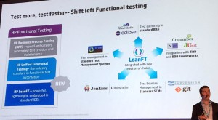

HP LeanFT is supposed to the change the way testing is done giving more powers to a new breed of DevTesters. LeanFT is basically build for SDET (Software development engineer in Test) or DevTesters only.

**So why another automation tool from HP when it has got UFT?**

**Were they missing something?**

**Were Competitors and New Tool Vendors cashing on lack of features in UFT?**

We try to uncover more of LeanFT right here in this post.

**The fact that HP LeanFT does not replace HP UFT and is built to create an integrated environment for Software Development answers most of the questions.**

So before I start discussing about HP LeanFT, one more announcement at HP Discover which I wanted to bring attention to is about UFT 12.5 and BPT 12.5.

HP announced a major upgrade to Unified Functional Testing or UFT and HP BPT (Business process testing). HP UFT 12.5 and HP BPT 12.5 will also be launched at same time as LeanFT i.e in July 2015. HP UFT 12.5 will share the same license as HP LeanFT.

[HP UFT share the same licence as LeanFT. Upgrade to HP #UFT 12.5, and get to use HP #LeanFT for…](https://twitter.com/share?text=HP+UFT+share+the+same+licence+as+LeanFT.+Upgrade+to+HP+%23UFT+12.5%2C+and+get+to+use+HP+%23LeanFT+for...&via=TestingVidya&related=TestingVidya&url=http://www.testingvidya.com/hp-leanft-overview-lean-functional-testing/)

[**Click To Tweet**](https://twitter.com/share?text=HP+UFT+share+the+same+licence+as+LeanFT.+Upgrade+to+HP+%23UFT+12.5%2C+and+get+to+use+HP+%23LeanFT+for...&via=TestingVidya&related=TestingVidya&url=http://www.testingvidya.com/hp-leanft-overview-lean-functional-testing/)

**Let’s check what’s new in UFT 12.5 and then compare it with LeanFT.**

HP UFT 12.5 complements LeanFT and not compete with it and a combination of both can be real solution to meeting the needs of business application agility.

### ****UFT 12.5 with New Features and Enhancements****

UFT, earlier known as QTP is an end to end business process testing tool with greater focus on graphical user interface testing (GUI testing). UFT serves to enhance the user experience by creating checkpoints and check functional aspects of the user interface of the application. The ability to test the API’s and components independently and then in an integrated environment makes it easier for Business analysts and Test automation engineers to automate the whole functionality and check for bugs.

UFT supports automation of web, mobile API and packaged applications. (Please note: You need to take the licenses for HP Mobile center[](http://www.testingvidya.com/wp-content/uploads/2015/06/UFT-logo.png) separately).

**Few Features of UFT that lets the test automation engineers automate the applications with ease and ensure quality are:**

* **Cross browser testing:** ability to test the application in all major browsers
* **Continuous Testing:** with LeanFT plugin, test creation in C# or Java leads to continuous integration, continuous delivery along with continuous testing
* **API and Web Service Testing :** integrations with ease
* **Mobile Application Testing:** Integrate with HP Mobile Center and get best app quality
* **Business Process Testing:** Keyword driven and scriptless test automation with BPT

**HP UFT 12.5** not only integrates with HP products like HP ALM, Quality center, mobile center and so on but also with Jenkins, SVN and GIT.

[#UFT with #BPT results in high acceleration with auto #test flow creation. @Testingvidya](https://twitter.com/share?text=%23UFT+with+%23BPT+results+in+high+acceleration+with+auto+%23test+flow+creation.+%40Testingvidya+&via=TestingVidya&related=TestingVidya&url=http://www.testingvidya.com/hp-leanft-overview-lean-functional-testing/)

[**Click To Tweet**](https://twitter.com/share?text=%23UFT+with+%23BPT+results+in+high+acceleration+with+auto+%23test+flow+creation.+%40Testingvidya+&via=TestingVidya&related=TestingVidya&url=http://www.testingvidya.com/hp-leanft-overview-lean-functional-testing/)

#### **So what’s New in UFT 12.5 / BPT?**

* **Better User Interface** : Keyword view enhancements and Lightweight HTML reports
* **Browser testing made easy:** Chrome and Firefox recording get an edge with Improved performance
* **SiebelOpenUI:** New object support
* **BPT:** Mobile support and recording of components in BTP test. Data use improvements.
* **UFT Execution Engine:** You don’t need the entire UFT IDE now
* **Mobile Testing:** Mobile test checkpoints and BPT integration for mobile

**So let’s begin uncovering HP LeanFT – Lightweight, Powerful and Developer Oriented Testing Tool**

In my previous post I had taken you through the journey of [HP Functional Testing Tools](http://www.testingvidya.com/hp-functional-testing-tool-review/) and shown how things are moving towards Agility and DevOps.

It’s good to understand about Agility and DevOps before we move to LeanFT and why a behemoth like HP released a functional testing tool catering to these concepts.

### ****What is Agility?****

[**Dictionary.com**](http://dictionary.reference.com/browse/agility) **defines Agility as:** the power of moving quickly and easily; the ability to think and draw conclusions quickly; intellectual acuity.

So how does it relate to software testing?

The whole Agile principles in Software development started with Agile [Manifesto](http://agilemanifesto.org/). It states that:

Individuals and interactions over processes and tools

Working software over comprehensive documentation

Customer collaboration over contract negotiation

Responding to change over following a plan

For me, Agility brings the Dev, Ops and Test Teams together resulting in great products sticking to above principles.

### ****What is DevOps?****

[Wikipedia](https://en.wikipedia.org/wiki/DevOps) defines DevOps perfectly. It states that: DevOps (a clipped compound of “development” and “operations”) is a software development method that stresses communication, collaboration, integration, automation, and measurement of cooperation between software developers and other information-technology (IT) professionals.

DevOps changes the complete cycle of entire Delivery timeline by bringing the Development, QA and Operations team together. This results in quicker deployment frequency, faster maintenance releases and improved reliability and security by virtue of QA teams being involved at every stage.

DevOps and Agile Development shares the same principles by granting more control to all the stakeholders and speeding up the whole process.

### ****Why so much Attention to Agility and DevOps?****

DevOps has been termed as an Evolution in making as it is not only brining the Dev and Ops team together from the siloes but the whole organization.

Traditionally, the Dev used to send the code and operations used to deploy it, simple right?

But there was always a cat and mouse game which used to go in background with hundreds of mails being exchanged.

Principles of DevOps brings the Dev and Ops at arm’s length and lets them focus on issues that really matter. Agile development puts additional pressure on Ops with more frequent deployment of code. To solve the problem, DevOps strives for cross-silo collaboration constantly, not only when things fail, which is the typical case in most agile driven organizations also.

So Operations is not treated as a separate unit but part of the whole development process.

Issues such as application stability, continuous monitoring, and creation of backups can be addressed immediately with this collaboration. Also Operations gets a better understanding of how the application actually works before it actually deploys it in production.

To achieve low lead times, Automation of build, deployment and testing is must and that’s what brings us to LeanFT.

[With #Agility and #DevOps covered, it is easy to understand why #LeanFT was released. @TestingVidya](https://twitter.com/share?text=With+%23Agility+and+%23DevOps+covered%2C+it+is+easy+to+understand+why+%23LeanFT+was+released.+%40TestingVidya&via=TestingVidya&related=TestingVidya&url=http://www.testingvidya.com/hp-leanft-overview-lean-functional-testing/)

[**Click To Tweet**](https://twitter.com/share?text=With+%23Agility+and+%23DevOps+covered%2C+it+is+easy+to+understand+why+%23LeanFT+was+released.+%40TestingVidya&via=TestingVidya&related=TestingVidya&url=http://www.testingvidya.com/hp-leanft-overview-lean-functional-testing/)

## **LeanFT: Lean Functional Testing – ‘Shifting Left’ as HP Calls it.**

[HP LeanFT](http://www.testingvidya.com/wp-content/uploads/2015/06/HP-LeanFT-logo.png)Lean functional Testing by HP is a powerful developer-oriented testing tool build specifically for Agile and DevOps environment. It enables the core principles of continuous delivery, continuous integration and continuous delivery.

Best suited for Developers and DevTesters, it’s a boon for Agile and DevOps centric teams.

LeanFT continuous ahead with UFT concepts and adopts Test objects and descriptions using Object identification mechanisms of UFT.

#### **LeanFT: Features, Technology support and how it works**

LeanFT supports a wide range of AUT (Application under Test) technologies. It gives more power to the developers especially and is a great step towards agility and creating a DevTesters.

* You can now develop tests in Visual Studio using C#. Comes as a plugin to Visual studio.
* You can now develop test in Eclipse using Java. Comes as a plugin to Eclipse.
* Open source TDD and BDD frameworks like Cucumber, NUnit and JUnit can now be integrated.
* Support for Source control and Version control tools like GIT, SubVersion.
* Supports Jenkins Integration
* Concept of Application Models enables modeling of AUT and its objects
* AUT technologies support for Windows Standard, Web, .NET Windows forms, WPF, Mobile and Insight Image Recognition

(Source: saas.hp.com)

#### **With LeanFT, creating a test project/script is sim**HP LeanFT working**ple few step process:**

* You create a testing project in choice of your IDE: Visual Studio or Eclipse.
* The projects is created with LeanFT libraries referenced and also testing framework libraries if installed.
* You them implement the test, add additional classes and build the project
* Using the internal Test Explorer you can run the tests to see the results
* You can now check the source in SCM and execute the tests in either CI system or ALM

### ****How is it HP LeanFT different from Unified Functional Testing (UFT)?****

[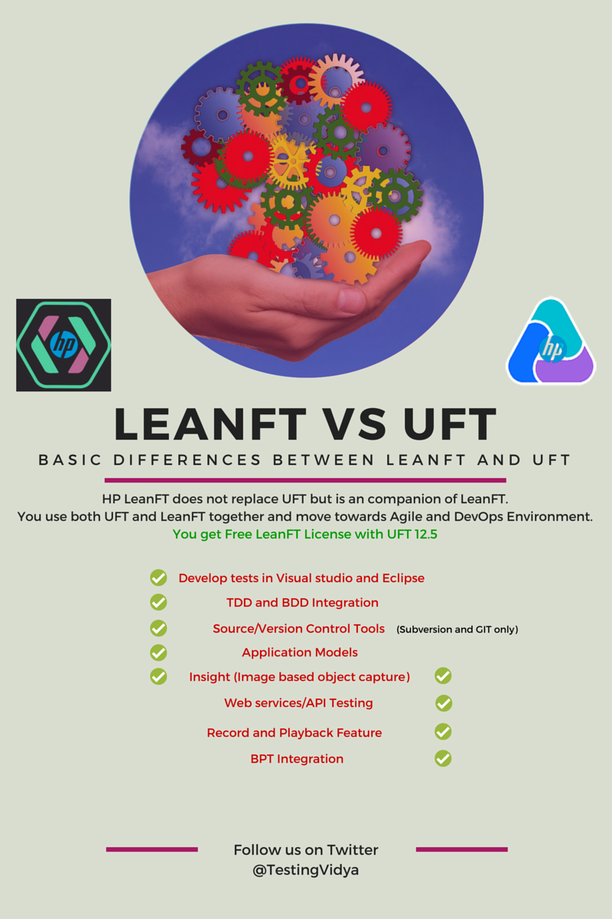](http://www.testingvidya.com/wp-content/uploads/2015/06/leanft-vs-uft.png)

HP LeanFT versus HP UFT

(Source: saas.hp.com – HP LeanFT Overview)

UFT and LeanFT are more similar than different with same Test Objects concept of UFT. LeanFT also adopts and enhances UFT tools like SPY and Object Repositories.

* LeanFT does not give you Record and Playback feature like UFT. It’s scripting only in LeanFT.
* Visual API testing/ Web service testing will still require you to use UFT
* Business process testing(BPT) integration is only with UFT
* UFT supports 20+ platforms for legacy, desktop and mainframe etc while LeanFT supports the AUT’s listed above.

### ****Which one to go for: HP UFT 12.5 or LeanFT?****

HP UFT and LeanFT can be mixed and matched based on your company’s needs. So a combination of both can be what will actually lead to agility. But HP has given a set of options for users who are looking to start using LeanFT.

**Options:**

1. Good news is that the Existing UFT Customers get LeanFT for Free.

2. But in case you want to go Agile but do not want to spend on the full license fee of UFT, HP allows you to take LeanFT only with Runtime Engine. Runtime Engine enables you to distribute and execute UFT test scripts across different computers or virtual machines without the need for a full UFT license or installation.

3. Finally, small Dev/ test teams also have the option of just going for LeanFT for CI/CD

**Converting scripts from UFT to LeanFT**

That’s one thing which businesses might be thinking about when LeanFT was launched.

#### **Do we have to migrate all our scripts to LeanFT now?**

Will HP end support to UFT?

**HP is not ending support to UFT.**

As already stated, LeanFT is not a replacement but a companion of UFT. With release of UFT 12.5 it is set to become even better.

Answer to Migrating from HP UFT to LeanFT is both Yes and No for me.

UFT objects repository is already compatible with LeanFT, but that will still involve lots of manual intervention/rewriting to convert script to choice of your language C# (for Visual studio) and Java (For Eclipse).

So if you are planning to use your existing UFT scripts to be used by Developers / DevTesters in LeanFT creating a more integrate environment. Answer is YES.

This will help you adopt to LeanFT features quicker and make things quicker leading to agility.

But in case you do not plan to get your scripts executed by Dev team than it does not make sense to convert them.

**A Quick search resulted in 2 companies offering the Migration solution from UFT to LeanFT:**

* **Gallop Solutions :** A US based testing firm, they are an HP partner and also present at HP Discover where they released their migration tool – QuickLean
* **Testing Performance:** UK based firm with their tool xMigrate.

Not much detail is available about both of them. Will cover once they are fully released.

#### **Concluding thoughts on LeanFT**

With UFT 12.5, a new version of BPT and LeanFT, HP is trying to address everybody involved in SDLC. Those who are not happy with lack of support in Selenium will be happy to switch to UFT+LeanFT combination.

With no more of VBScript involved , it might be a steep learning curve for Testers who are accustomed to it, but Java and C# are better alternatives and will lead to more collaboration between Dev and Test Teams leading to CI, CD and CT.

<http://www.testingvidya.com/hp-leanft-overview-lean-functional-testing/>

# **A sneak peek at Lean Functional Testing (LeanFT)**

[leanFTSneakPeek](https://www.joecolantonio.com/wp-content/uploads/2015/06/leanFTSneakPeek1.jpg)

Luckily, at the last minute I was able to get a ticket (thanks Malcolm!) to [HP Discover](http://discover.hp.com/Discover) in Las Vegas, and I’m glad I did. During the conference, HP announced the new and soon-to-be-released automation tool, Lean Functional Testing (LeanFT), which I think is going to be an automation game changer.

Essentially, Lean Functional Testing (LeanFT) combines the best of both the vendor-based and open-source worlds by morphing Selenium with some key functionality currently found in UFT.

#LeanFT combines the best of both vendor-based and open-source worlds by morphing Selenium with some key functionality found in UFT.

Click to tweet

## **Why yet another automation tool?**

HP built LeanFT from the ground up to address the growing modern automation demands of continuous testing, mobile and dev-ops. What’s really cool is that LeanFT fits into your developer’s ecosystem, so your developers can still use their favorite IDEs, programming languages and unit testing frameworks, not to mention the added benefit of access to HP Web/Windows-based technologies that Selenium does not provide.

Remember — Selenium is only for browser-based testing, and does not handle non browser-based popups and windows. This is a major issue, as most experienced testers working in an Enterprise environment will tell you. Quite often our test scripts have to deal with more than just web-based interactions.

## **An Automation Dilemma**

For example, many end-to-end workflows involve dealing with Windows or Windows-based applications or pop-ups. Cobbling together a solution using Selenium and some other libraries to automate these non-browser based features is difficult and often less than reliable.

I, for one, work automating a modern [AngularJS](https://angularjs.org/) application, around which I created a Selenium/Java automation framework, but over the past few month more and more new functionality has been introduced that requires our Web apps to integrate with some thick client applications.

You can imagine my automation dilemma.

Our company’s goal is to try automating as many tests as possible, and most of these integration tests could not be handled within the current framework. So what do you think happened? Rather than creating a bunch of manual tests, we ended up creating a second framework in UFT to handle those particular types of tests.

This approach caused all manner of confusion, because I had to ensure that we used the right framework for the right tests as well as maintain two separate code bases — a real nightmare scenario. LeanFT solves this issue.

With LeanFT, I can now use my existing Selenum/Java framework and still be able to handle these integration-type tests!

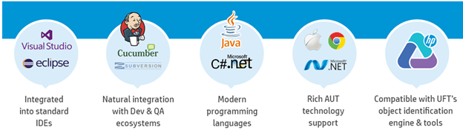

## **UFT automators are no longer second-class citizens**

Using LeanFT provides its users access to a bunch of new tools that make testing in Selenium much easier — like the object identification center (think QTP GUI spy), that allows you from Visual Studio or Eclipse IDE to quickly spy on objects and identify unique values to use for your object identification.

Also — in another non-HP-like move, if you have an existing UFT license you automatically have access to LeanFT at no additional cost. You’ll now have the option to create UFT, LeanFT scripts or a combination of both.

## **The main features of LeanFT**

Here are the main features and functionality that I was able to gather at the conference that LeanFT will include:

Main Features:

•    IDE support for Visual Studio and Eclipse

•    Write scripts in real modern languages C# and Java

•    Support for Web, Standard Windows, .NET/WPF, SAPUIS, Mobile, Java

•    Integration with:

•    Git, SvN

•    Jenkins, TFS

•    Cucumber, jBehave

•    ALM

Main Functionality:

•    Object Identification Center – like the UFT Spy is a tool for object identification related stuff

•    Application Models – are abstractions of your application under test that provide your tests with an interface to the application and it object

•    HTML Run Report

•    Insight Mode

Now I know many of you are thinking what does this mean for me if I’m a UFT user? Do you have to move over to LeanFT?

## **LeanFT does not replace UFT**

A key point to keep in mind is that LeanFT does not replace UFT! They are two separate products that address different issues. Your situation and organization will dictate which tool you choose.

Basically HP talked about three main users they thought about DevTesters, Test Automation Engineers and Subject Matter Experts and what their different requirements are to help explain how each tool fits with each user type.

## **DevTester**

This is the technical tester who is probably already using Selenium with C# or Java but is missing some of the functionality they had to leave behind when they moved over from UFT. These users are the target audience for LeanFT

## **Test Automation Engineers**

These are the users that have already built automation framework in UFT and have some knowledge of other languages but have been perfectly happy with UFT. They will most likely continue to use UFT but based on projects might dabble with LeanFT.

## **Subject Matter Experts/Business Testers**

These are your non-technical users who most likely will not have a need to LeanFT. They will continue to use tools like Business Process Testing (BPT) and Script less keyword driven approaches to automation.

For the users that most likely would not be using LeanFT don’t’ worry HP also made some other announcement about enhancement to [UFT 12.5](https://www.joecolantonio.com/2015/06/10/uft-a-sneak-peek-at-unified-functional-testing-12-5/) that I will cover in another post.

And once against if you already have a UFT license you do not have to choose one of the other. You can mix and match depending on your projects needs.

**Win/Win**

If you’ve been torn between sticking with UFT or jumping over to Selenium now you have a better option –LeanFT. You can leverage your exiting UFT experience and knowledge and move to the same development environment your developers are using. This will significantly shorten your learning curve in having to pick up Selenium.

Most important you no longer will you feel like a second-class developer’s citizens being stuck with lame VBScript. You’ll now have the power of using Java or C# and be able to use the same unit testing frameworks and tools as your dev’s.

Bonus this should help foster better collaboration between you and your developers.

Our friends at HPE decided to skip UFT 13 altogether. Whether it is due to the number 13  – being considered unlucky in some parts of the world – remains to be seen. The latest version for HPE Unified Function Testing is UFT 14.

Beginning Jan 31, 2017, UFT has been upgraded from [UFT 12.54](https://www.learnqtp.com/uft-12-54-features/) to UFT 14.00



Here are the 9 most important things to note about the latest version.

## **1. Upgrade to UFT 14**Upgrade UFT 14

* If you are on [UFT 11.5](https://www.learnqtp.com/hp-uft11-5-qtp-new-features/) or above version, you can directly run the **SetUp** to upgrade to UFT 14.
* If you are on UFT/QTP version earlier than 11.5, you need to uninstall the current version of QTP and then install UFT 14.
* If you are upgrading from a version of UFT earlier than 12.5, you should get a new license. Since UFT 12.5, HPE has moved from [Sentinel to AutoPass licensing mechanism](https://www.learnqtp.com/uft-license-autopass/).

## **2. More UFT Editions**

UFT is now offered in 3 new flavors. UFT Ultimate, UFT Enterprise, and UFT Pro.

* If you previously had a UFT License, it will now be renamed to UFT Enterprise.
* If you previously had a LeanFT License, it will now be renamed to UFT Pro (LeanFT).
* While UFT Enterprise and UFT Pro are available as seat license as well as concurrent license, UFT Ultimate is available only as a concurrent license.
* Starting with UFT 14, UFT will now support device id based concurrent licenses in addition to concurrent license based on license server IP address.
* UFT RunTime Engine licensing remains the same.

The UFT Runtime Engine enables you to run UFT GUI tests, API tests and Business Process Tests on your computer without installing the entire UFT IDE.

Here is the complete matrix for the new license editions offered by HPE UFT.

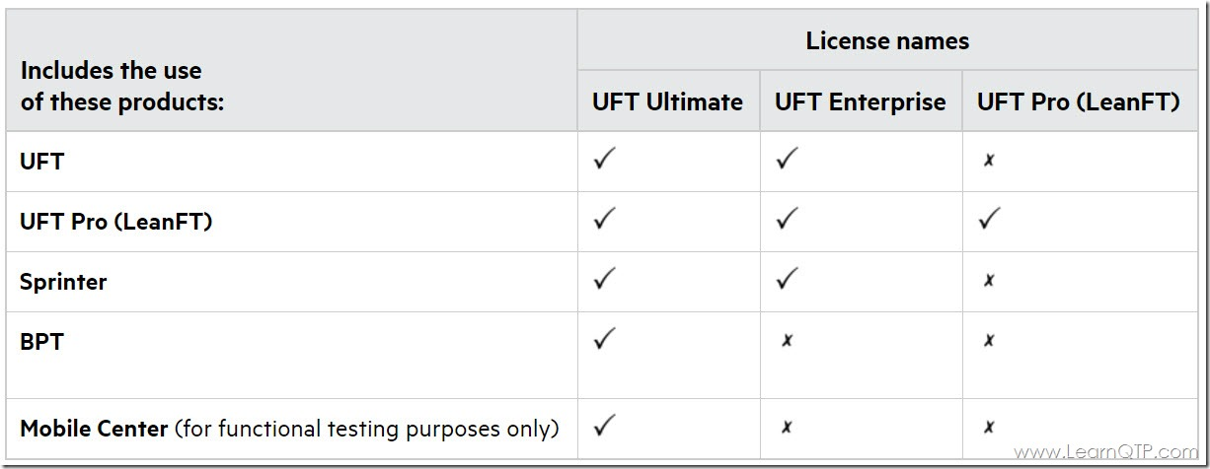

[Source](http://uft-help.saas.hpe.com/en/14.00/UFT_Help/Content/User_Guide/UFTLic_LicenseCategories.htm)

## **3. UFT 14 Look and Feel**

Installation setup, launch splash screen, and record-and-run settings screen have a new look now. Green color has taken a front seat across various buttons, progress bars and font color in UFT IDE.

This is the setup screen sequence you will see when you click setup.exe for the first time. Other than the variation in background-color-theme, there isn’t any difference when compared to the earlier UFT versions.

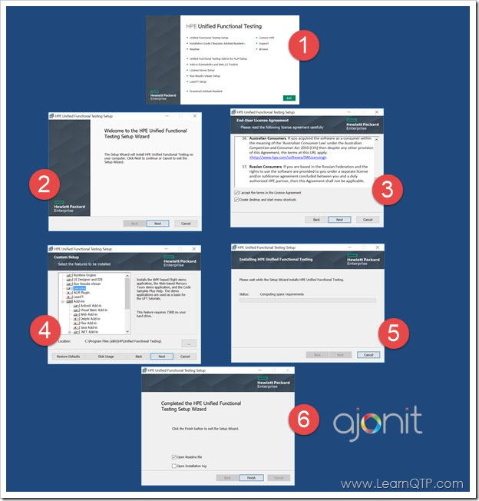

Once UFT is installed, this is the look of the new splash screen.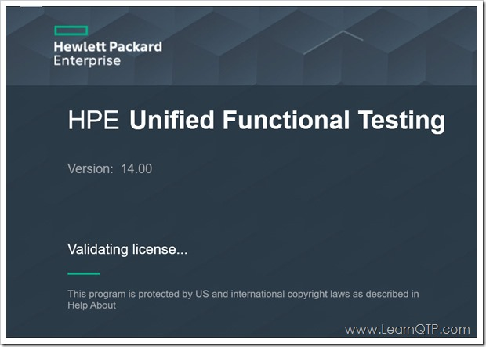

The Add-in manager screen.

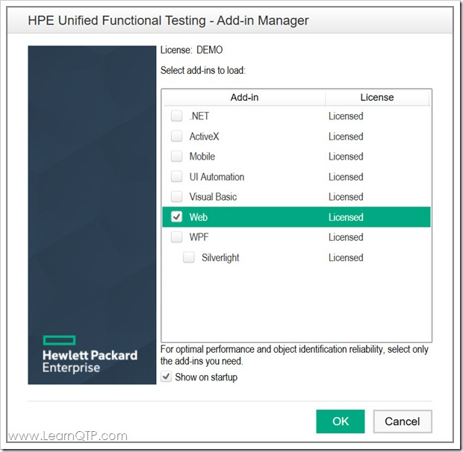

The Record and Run Settings screen has undergone a visual change. No new feature is introduced and no functionality seems to be altered.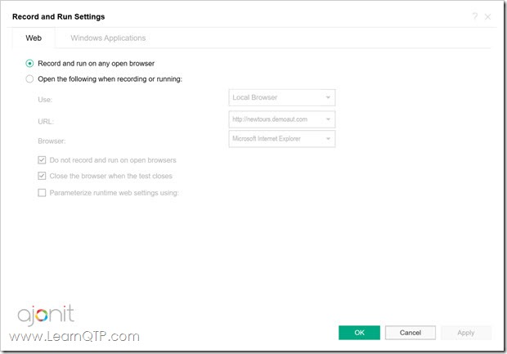

## **4. Data Generator or Test Combinations Generator for GUI tests**

Getting relevant test data has always been one of the challenges of automated testing. Till now, one has to rely on [3rd party tools for test data](https://www.learnqtp.com/generate-test-data-for-software-testing/) needs.

Starting with UFT 14, UFT has introduced a new tool inside the UFT IDE called Test Combinations Generator.

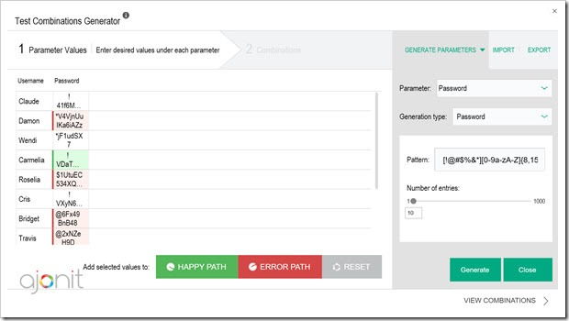

When a GUI test tab (flowchart) is in focus in the Editor, you will find a new button in the Toolbar.Test Combinations Generator button

Clicking this button will launch the Test Combinations Generator tool. Using this tool, you can automatically generate data for various types of values you need.

The most common types of data values needed can be selected from the drop-down on the right side as shown in the image above. For each value type, there are various combinations that can be chosen. For example, in date value type you can choose the minimum date, maximum date and the format of the date that you wish to generate.

Once the data is generated, you can do further voodoo on it. You can select the values to be recognized as HAPPY PATH which means the value is expected not to cause an exception or error OR it can be an ERROR PATH which means the values is expected to cause an exception or error. (useful for negative testing).

Values designated as HAPPY PATH or ERROR PATH can then be seen and applied in the data table using the Test Combination Generator button.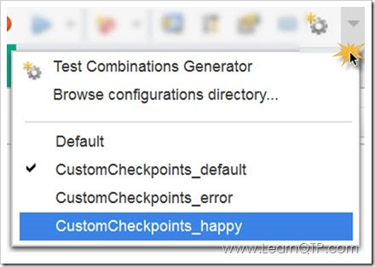

The data can be mixed and matched or you can choose to JOIN the data which means no permutations will be allowed further.



Join the columns in TCG

## **5. New “Capture” Mode**

Using the newly introduced Capture button on the toolbar, you can capture all the objects in a selected area of your application.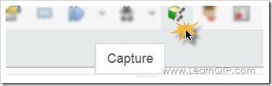

I would want to know and explore the use cases for this feature and how is it better than **Navigate and Learn** which is already available in the object repository manager.

## **6. UFT Help Moved To New Location**

UFT help files have been moved to online by default. I don’t get the rationale behind this move. There is nothing faster than having and retrieving files from your own system. Moreover, it will be a pain for those on VPN with limited or no access to the internet.

However, to HPE’s credit, they haven’t removed the local help completely. You can still configure the help files so that they can reside on your machine and can be launched using the favorite shortcut F1.

Here are the steps to configure UFT help on your local machine.

1. [Download UFT 14 Help file](http://uft-help.saas.hpe.com/en/14.00/UFT14.00HELP.ZIP)
2. The download is in the form of a zip file. Extract the contents to <UFT installation folder>/help. Most likely the location would be C:\Program Files (x86)\HP\Unified Functional Testing\help
3. In UFT, go to Tools > Options > Help and select **Access local Help** radio button.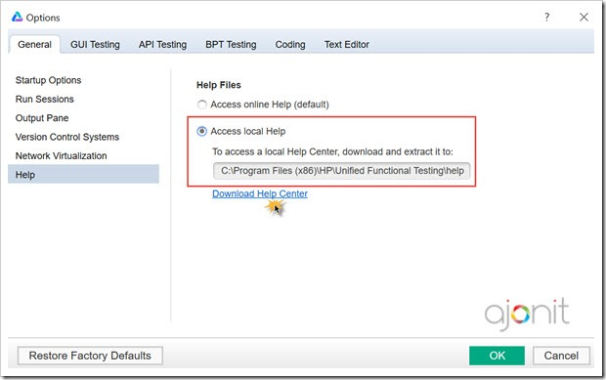

## **7. UFT Pro (LeanFT) goes cross platform**

LeanFT is now supported across Windows, Mac OS and Linux for your web and mobile testing needs.

For web testing, you would get all capabilities you had in Windows version.

You should, however, note in case of mobile testing you still need to create scripts on Windows OS. Only **execution** is supported on Mac OS and Linux.

## **8. LeanFT for Selenium**

Selenium has seen a high rate of adoption in the past few years. HPE has developed a solution **LeanFT for Selenium** which is bundled with HPE UFT Pro (LeanFT). It enables Selenium users to create and maintain Selenium scripts easily. **LeanFT4Selenium** is available for Windows, Linux, and Mac, and supports the most common browsers.

You can learn more about it on [Yossi’s excellent article](https://community.hpe.com/t5/All-About-the-Apps/Using-Selenium-for-Web-Automation-Let-UFT-Pro-LeanFT-help-you/ba-p/6932523#.WJHI1_l97b0).

## **9. Other Changes and Enhancements**

* UFT now supports the latest versions of Firefox and Chrome including Chrome v56. [Trivia: With the launch of Chrome 56, Google has started marking web pages “Not secure” that accept sensitive info like passwords and credit card on plain HTTP]
* UFT now supports sensor simulation operations on Mobile devices.
* You can use API tests of your application when the service level uses the [MQTT protocol](http://mqtt.org/documentation) for communication.
* UFT 14 is now available in six languages which include English, Chinese, Japanese, Russian, French, and German.
* UFT now supports Windows Server 2016, AutoPass License Server 9.3,  EXT-JS 6.0, SiebelOpenUI 16, Safari 10.12, SAPUI5 1.38, Visual Studio 2015, Solution Manager 7.2, Delphi Berlin 10.1, SAP Hybris.

<https://youtu.be/dnyp9iFKICE-leanft> video